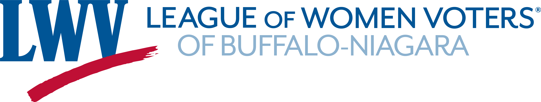

Census 2020: Make Sure We Count Everyone

What is the census?
The census is a count of every person who lives in the United States and its territories. The U.S. Constitution requires this count every 10 years. Your response is a civic duty.

Why is it so important?
Your responses inform where more than $675 billion is distributed each year to communities nationwide for clinics, schools, roads and more. That translates to $2,600 for each person who is living in our county at census time. The census also determines the number of representatives each state will have in the House of Representatives and is used to redraw legislative district lines.

Get counted online – it’s easy!
Simply complete the census online at https://my2020census.gov or call the Census Bureau at 844-330-2020. It takes just a few minutes, and one person from your household completes it for everyone who was living at your address on April 1, 2020.

When?
The first invitation has been mailed to residents, but it’s faster and easier to respond online or by phone. (In May, the Census Bureau intends to begin following up in person with households that have yet to respond, but this may change depending on the Covid-19 pandemic.)

What if you haven’t received an ID in the mail?
You can complete the census online using your street address.

What if you get another request?
It takes the Census Bureau one week to process the information received, so you might get a second request when you've just responded. You need to respond only once.

What if you have a P.O. box?
People who receive their mail at a P.O. box, rather than a street address, have their census request hand delivered, and that has been delayed. The Census Bureau prefers that you use the phone or go online using your address for ID.

Hooray for Erie County!
As of April 6, Erie County has achieved the best response rate in New York State – 49%. Ten years ago, our response rate was 69% – surely we can beat that record this time around! We have until August 15 to complete the census.

Safe and secure
Responses to the 2020 Census are safe, secure and protected by federal law. Your answers cannot be used against you by any government agency or court in any way – not by the FBI, not by the CIA, not by the DHS, and not by ICE. Your responses can be used only to produce statistics.

During the 2020 census, the Census Bureau will never ask you for:
- Your Social Security number.
- Money or donations.
- Anything on behalf of a political party.
- Your bank or credit card account numbers.
If someone claiming to be from the Census Bureau contacts you via email or phone and asks you for any of these things, it's a scam, and you should not cooperate.

The bottom line
Make sure you’re counted! And offer a friendly reminder to family, friends and neighbors to make sure they’re counted too.

This information was presented to attendees at the League’s program on March 12, 2020, and recently updated by Amy A. Brombos, Supervisory Partnership Specialist at the New York State Regional Census Center.

